Amazon Route 53 Failover Routing

Lab overview
In this activity, you configure failover routing for a simple web application.
The activity environment starts with two Amazon Elastic Compute Cloud (Amazon EC2) instances that have already been created. Each of the instances has the full LAMP stack installed and the café website deployed and running. The EC2 instances are deployed in different Availability Zones. For example, if the web servers are running in the us-west-2 Region, then one of the web servers runs in the us-west-2a Availability Zone and the other one runs in the us-west-2b Availability Zone.
You will configure your domain such that, if the website in the primary Availability Zone becomes unavailable, Amazon Route 53 will automatically fail over application traffic to the instance in the secondary Availability Zone.
When you are finished, your environment will look like the following architecture:

Amazon Route 53 Failover Routing

Lab overview
In this activity, you configure failover routing for a simple web application.
The activity environment starts with two Amazon Elastic Compute Cloud (Amazon EC2) instances that have already been created. Each of the instances has the full LAMP stack installed and the café website deployed and running. The EC2 instances are deployed in different Availability Zones. For example, if the web servers are running in the us-west-2 Region, then one of the web servers runs in the us-west-2a Availability Zone and the other one runs in the us-west-2b Availability Zone.
You will configure your domain such that, if the website in the primary Availability Zone becomes unavailable, Amazon Route 53 will automatically fail over application traffic to the instance in the secondary Availability Zone.
When you are finished, your environment will look like the following architecture:
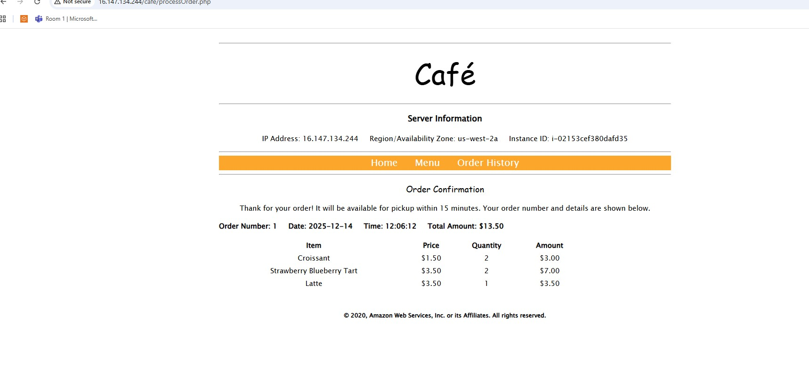

Task 2: Configuring a Route 53 health check
The first step to configure failover is to create a health check for your primary website.
- In the AWS Management Console, from the Services menu, enter and choose Route 53 to open the Route 53 Management Console.
You can safely ignore any error messages displayed because of AWS Identity and Access Management (IAM) restrictions placed on lab accounts.
- In the left navigation pane, choose Health checks.
- Choose Create health check, and configure the following options. Leave the default values for all other fields.
  - Name: Enter Primary-Website-Health
  - What to monitor: Choose Endpoint.
  - Specify endpoint by: Choose IP address.
  - IP address: Paste in the Public IPv4 address of CafeInstance1. You can find this value in the EC2 console, or you can copy the IP address from the CafeInstance1IPAddress value that you copied earlier.
  - Path: Enter cafe
- Expand Advanced configuration, and configure the following options. Leave the default values for all other fields.
  - Request interval: Choose Fast (10 seconds).
  - Failure threshold: Enter 2
- These options make your health check respond faster.
- Choose Next.
- For Get notified when health check fails, configure the following options:
  - Create alarm: Choose Yes.
  - Send notification to: Choose New SNS topic.
  - Topic name: Enter Primary-Website-Health
  - Recipient email address: Enter an email address that you can access.
- Choose Create health check.
Route 53 now checks the health of your site by periodically requesting the domain name that you provided and verifying that it returns a successful response.
The health check might take up to a minute to show a Healthy Status. Choose the refresh icon to update your view of the current status.
- Select Primary-Website-Health, and then choose the Monitoring tab.
This tab provides a view of the status of the health check over time. It might take a few seconds before the chart becomes available. Choose the refresh icon to update your view.
- Check your email. You should have received an email from AWS Notifications.
- In the email, choose the Confirm subscription link to finish setting up the email alerting that you configured when you created the health check.
- 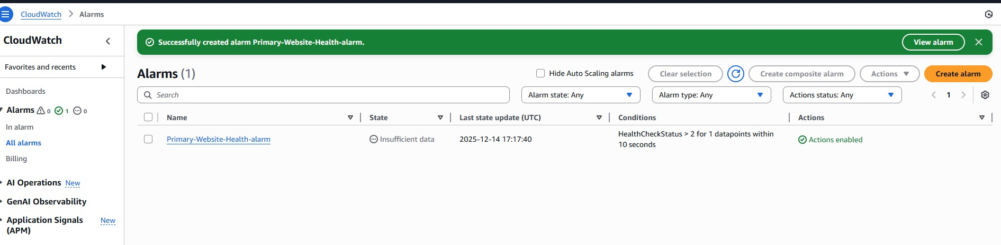

Task 3: Configuring Route 53 records
In the following tasks, you create Route 53 records for the hosted zone.

Task 3.1: Creating an A record for the primary website
You now configure failover routing based on the health check that you just created.
- In the Route 53 console, in the left navigation pane, choose Hosted zones.
The domain name XXXXXX_XXXXXXXXXX.vocareum.training (where the Xs are digits unique to your AWS account) has already been created for you.
All lab participants have been given a unique domain name.
- Choose XXXXXX_XXXXXXXXXX.vocareum.training to display the two records that already exist in this hosted zone.
These two records were created when the domain was registered with Route 53. The NS, or name server record, lists the four name servers that are the authoritative name servers for your hosted zone in the Value/Route traffic to column. You should not add, change, or delete name servers from this record.
The SOA, or start of authority record, identifies the base Domain Name System (DNS) information about the domain in the Value/Route traffic to column. It was also created when the domain was registered with Route 53.
- Choose Create record, and configure the following options:
  - Record name: Enter www
  - Record type: Choose A - Routes traffic to an IPv4 address and some AWS resources.
  - Value: In the text box, enter the IP address for CafeInstance1IPAddress.
  - TTL (seconds): Enter 15
  - Routing policy: Choose Failover.
  - Failover record type: Choose Primary.
  - Health check ID: Choose Primary-Website-Health.
  - Record ID: Enter FailoverPrimary
- Choose Create records.
The A-type record that you created should now appear as the third record on the Hosted zones page.

Task 3.2: Creating an A record for the secondary website
Now you create another record for the stand-by/secondary web server.
- Choose Create record, and configure the following options:
  - Record name: Enter www
  - Record type: Choose A - Routes traffic to an IPv4 address and some AWS resources.
  - Value: In the text box, enter the IP address for CafeInstance2IPAddress. To find this value, at the top of these instructions, choose Details, and then choose Show, or copy it from the values that you pasted into a text editor earlier in the lab.
  - TTL (seconds): Enter 15
  - Routing policy: Choose Failover.
  - Failover record type: Choose Secondary.
  - Health check ID: Leave this field empty.
  - Record ID: Enter FailoverSecondary
- Choose Create records.
Another A-type record should now be listed on the Hosted zones page.
You have now configured your web application to fail over to another Availability Zone.

- 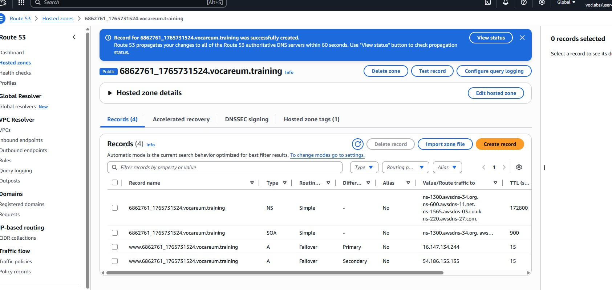

Task 4: Verifying the DNS resolution
In this task, you visit the DNS records in a browser to verify that Route 53 is pointing correctly to your primary website.
- Select the check box for either one of the A records. A Record details panel appears that includes the Record name. Copy the Record name value of the A record.
- Open a new browser tab. Paste the A record name, enter /cafe at the end of the URL, and then load the page.
The café primary website should load, as indicated by the Server Information section of the page, which should display the Region/Availability Zone.
Tip: The URL should be http://www.XXXXXX_XXXXXXXXXX.vocareum.tr
- 

Task 5: Verifying the failover functionality
In this task, you try to verify that Route 53 correctly fails over to your secondary server if your primary server fails. For the purposes of this activity, you simulate a failure by manually stopping CafeInstance1.
- Return to the AWS Management Console. On the Services menu, enter and choose EC2 and then choose Instances.
- Select CafeInstance1.
- From the Instance state menu, choose Stop instance.
- In the Stop instance? window, choose Stop.
The primary website now stops functioning. The Route 53 health check that you configured notices that the application is not responding, and the record entries that you configured cause DNS traffic to fail over to the secondary EC2 instance.
- On the Services menu, enter and choose Route 53
- In the left navigation pane, choose Health checks.
- Select Primary-Website-Health, and in the lower pane, choose the Monitoring tab.
You should see failed health checks within minutes of stopping the EC2 instance.
- Wait until the Status of Primary-Website-Health is Unhealthy. If necessary, periodically choose refresh. It might take a few minutes for the status to update.
- Return to the browser tab where you have the vocareum_XXXXXX_XXXXXXXXXX.training/cafe website open, and refresh the page.
Notice that the Region/Availability Zone value now displays a different Availability Zone (for example, us-west-2b instead of us-west-2a). You are now seeing the website served from your CafeInstance2 instance.
If you do not get the correct results, reconfirm that the Status of Primary-Website-Health is Unhealthy, and then try again. It might take a few minutes for the DNS changes to propagate.
- Check your email. You should have received an email from AWS Notifications titled "ALARM: Primary-Website-Health-awsroute53-..." with details about what initiated the alarm.
- 